**Project name : moodly**  
**Starting Date** : 25 July 2020  
**Finishing Date** : 29 July 2020

**Desc**

Moodly is a web which promoting models’ to provide some services such as Branding Product, Marketing model, etc. the web is made by HTML,CSS, and Vanilla Javascript (without any framework). The page contains 3 sections, those are slider which shows latest model with picts and data, about us section which explain what do we serve, and pricing with 3 option of package. The web is mainly focused on Front End, and didn’t use any Back End Language. The page is compatible with desktop resolution with **1270px-1920px.**

**Evaluation**

Since I didn’t use any backend language and database server, I still depend on making data with javascript. I relied on object and array to provide the data in slider. At start I was thinking of using setter getter or constructor for data. But it seems calling exported variable is better, since I use array for sliding the data.

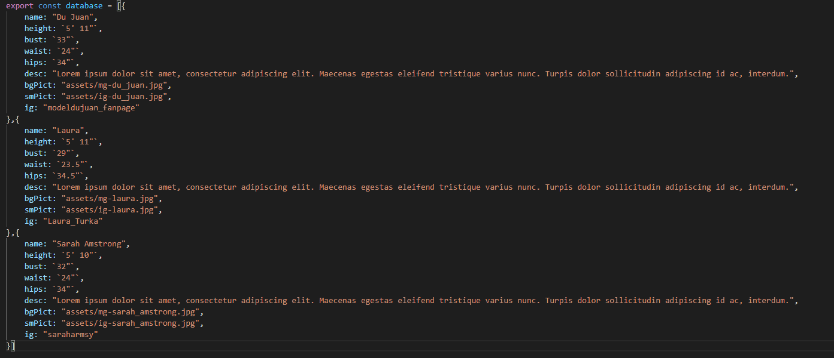

At the about us section, at start, I wanted to try giving animation like popping photo orderly in photo layout by using for and setTimeout. It didn’t work, instead it still popping all in one. So the **alternative** I used was using transition time that I plus by 1s per photo. For example the first photo come out in 3s then the second photo is coming out in 4s, etc.

Lastly the pricing option, I used scaling, when it’s hovered by mouse pointer.

**References**

1. Unsplash.com
2. Imgmodels.com